13 Editors - Video Sequence Editor
Video Sequence Editor 3
Type of Sequencer View 3
Drag n Drop 4
Last operator Add Movie / Image etc. Strip 4
Relative Path 4
Start Frame 4
End Frame 4
Channel 4
Replace Selection 4
Sound 4
Use Movie Frame rate 4
Navigating in the viewport 4
Hotkeys 4
Strips 5
Strip Types 5
Move Strips 5
Resizing strips 5
Last operator Sequence Slide 5
Offset X 5
Y 5
Sequencer - Sequencer context menu 6
Split 6
Last operator Split Strips 6
Frame 6
Channel 6
Type 6
Use Cursor Position 6
Side 6
Copy 6
Paste 6
Duplicate Strips 7
Rename 7
Delete 7
Slip Strip Contents 7
Last Operator Trim Strips 7
Offset 7
Snap Strips to the current frame 7
Last Operator Snap Strips to the current frame 7
Frame 7
Set Preview Range to Strips 7
Remove Gaps 7
Last operator Remove Gaps 7
All Gaps 7
Insert Gaps 7
Last operator Insert Gaps 8
Frames 8
Cross fade Sounds 8
Fade 8
Last operator 8
Fade Duration 8
Fade Type 8
Clear Fade 8
Movie Strip 8
Set Render Size 8
Deinterlace Movies 8
Make Meta Strip 8
UnMeta Strip 9
Toggle Meta 9
Lock/Mute 9
Lock Strips 9
Unlock Strips 9
Mute Strips 9
Last operator Mute Strips 9
Unselected 9
Unmute Strips 9
Last operator Unmute Strips 9
Unselected 9
Mute unselected strips 9
Last operator Mute Strips 10
Unselected 10
Unmute deselected Strips 10
Last operator Unmute Strips 10
Unselected 10
Quick Favorites menu 10
Hotkey only functionality 10
Context Set - O 10

Video Sequence Editor

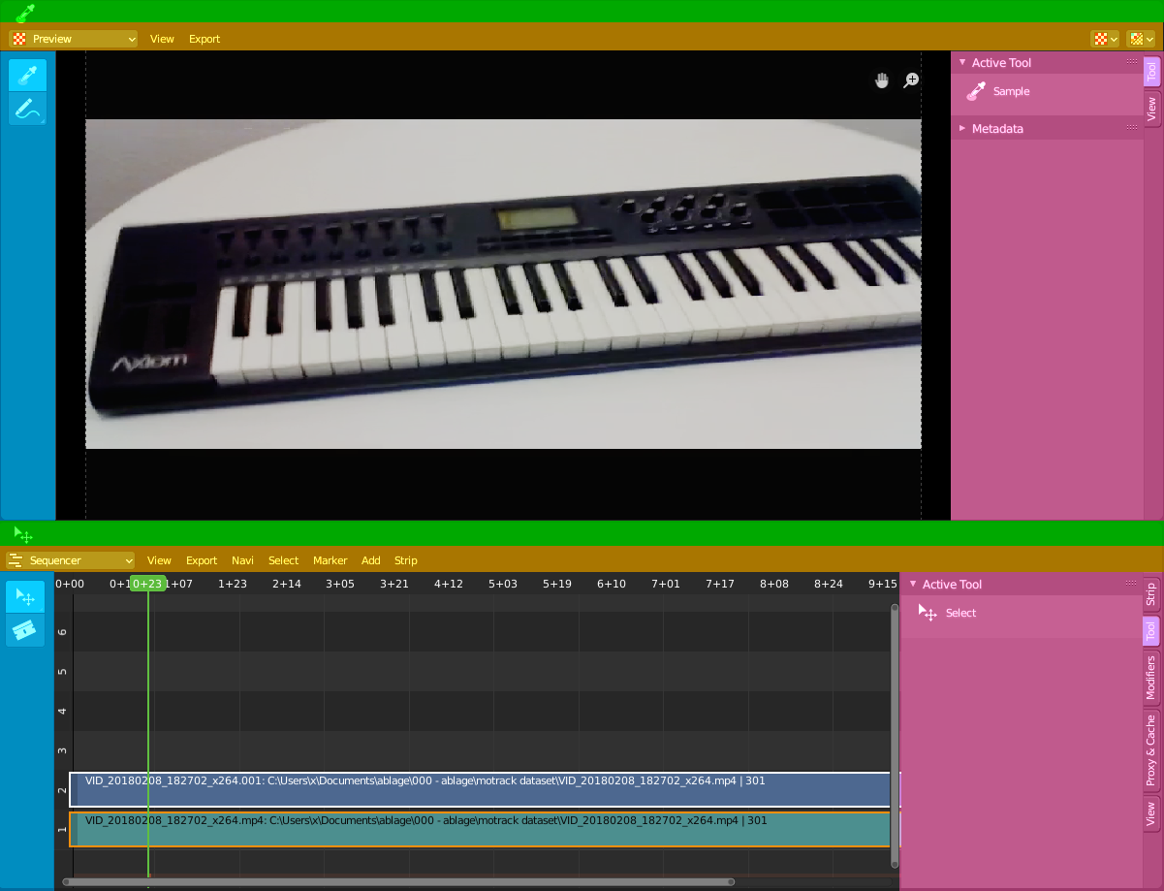
The Video Sequence Editor is a complete video editing system. It allows you to cut videos and add effects and audio.

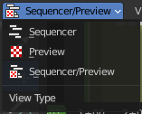
Type of Sequencer View
The Video Sequence Editor is two editors in one. The Preview sequencer view is a preview window. Here plays the video. The Sequencer sequencer view is the view that contains the the video and audio strips. The third method is both editor view types in one editor.

Both editor view types are divided into several areas.

Green - Tool area. Note that, different from the 3D view, the tool area cannot be hidden away.
Yellow – Header
Blue - Tool Shelf
Pink - Sidebar

Drag n Drop
You can drag n drop several elements like movie and audio clips into the Sequencer timeline. In this case you get the import options from the file browser displayed in the adjust last operator panel. The settings are pretty similar.

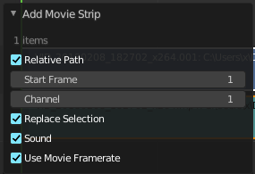
Last operator Add Movie / Image etc. Strip
When you drop a strip then you will get a last operator panel down left.

Relative Path
Select the file relative to the blend file.

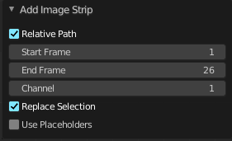
Start Frame
The start frame of the strip.

End Frame
The end frame of the strip

Channel
The channel to place this strip into.

Replace Selection
Replace the current selection.

Sound
Load the audio of the movie.

Use Movie Frame rate
Use the frame rate from the movie to keep sound and video in sync.

Navigating in the viewport

Hotkeys
Pan the view - MMB
Zoom - Mouse Wheel, MMB+CTRL, Numpad + / -
View All - Home
Deselect - left click into the off.
Select - left click
Add to selection - Shift + left click

Strips
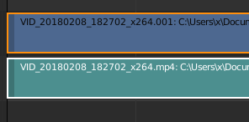
An element in the sequencer timeline is called strip. Strips are represented as bars.
Every strip displays the name of the strip up left.

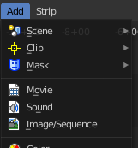
Strip Types
Videos can also contain audio. When you import a video with audio, then you will have two strips in the timeline. A video strip that contains the image material. And an audio strip that contains the sound.
But the sequencer does not only display video and audio strips. There are several more strip types available. You can in the Add menu load image sequences, single images, masks, and even whole scenes.

Move Strips
To move strips in the sequencer timeline select the strip and drag it. Upwards will put it into another channel. Sidewards will move it in the timeline.

Resizing strips
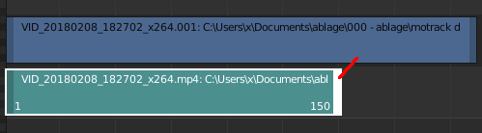
A strip has a drag handler at the left and a drag handler at the right. This handler allows you to resize the strip.

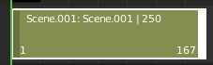
When the handlers are active you will see the frame numbers at the start and/or end of the clip. You can't move the strip as a whole while one of the handlers is active. Click in the off to deactivate the handlers. Then you can move the whole clip again.

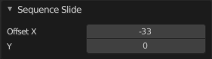
Last operator Sequence Slide
This adjust last operator shows for both, move strips and resize strips.

Offset X
The modified frame position, relative to the start position of the strip.

Y
The modified channel position, relative to the start position of the strip.

Sequencer - Sequencer context menu

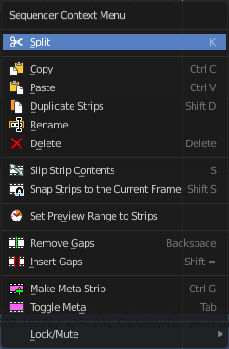
When you double right click into the Sequencer view, then you will open a menu. The Sequencer Context menu. Its content is to 100% double content to already existing menu entries. And it is despite the name not contextual.

Split
Splits the selected strips at the chosen mouse position.

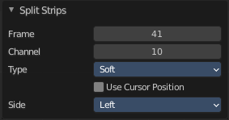
Last operator Split Strips

Frame
The frame at which the split happens.

Channel
The channel

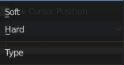
Type
Split type. Soft or hard.

Use Cursor Position
Split the strip at the cursor position instead of the current frame.
This feature is pretty useless since you adjust this setting afterwards, after you have already cut at the current frame. There is no cursor position available anymore.

Side
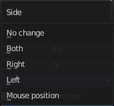
The side that remains selected after splitting.

Copy
Copies the selected strips.

Paste
Pastes the copied strips. The strip will be pasted to the next free channel.

Duplicate Strips
Duplicates the selected strips. The duplicate will stick to the mouse. Move the duplicate with the mouse, then click to release. In case of overlapping strips the duplicate will snap behind the strip under the mouse.

Rename
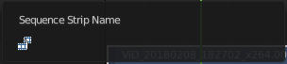
Allows you to rename the current active strip. A popup opens up where you can type in another name.

Delete
Deletes the selected nodes. All Connections gets removed.

Slip Strip Contents
The Slip tool allows you to change the position of the contents of a strip without moving the strip itself.

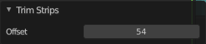
Last Operator Trim Strips

Offset
The offset of the content to the strip.

Snap Strips to the current frame
Snaps the selected strips to the current frame.

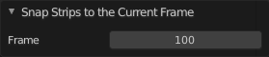
Last Operator Snap Strips to the current frame

Frame
The frame to snap to.

Set Preview Range to Strips
Sets the preview range to the selected strips. The playback will then happen in this range.

Remove Gaps
Snaps the selected strip to the end of the strip before the selected one.

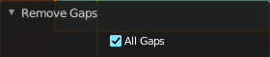
Last operator Remove Gaps

All Gaps
Snaps all strips to the ends of the previous strips to close all gaps.

Insert Gaps
Insert a gap of frames before the selected strip.

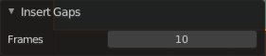
Last operator Insert Gaps

Frames
The number of frames to insert.

Cross fade Sounds
Cross fade two selected audio strips.

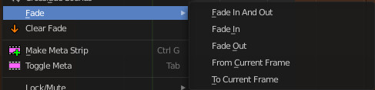
Fade
Fade effects for strips. The names should be self explaining.

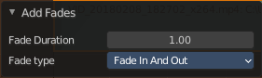
Last operator

Fade Duration
The duration of the fade.

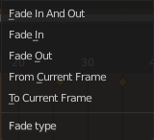
Fade Type
The fade type to choose.

Clear Fade
Clears the fade effects at the selected strips.

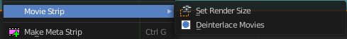
Movie Strip

Set Render Size
Sets the render resolution and aspect to match the strip’s resolution.

Deinterlace Movies
Converts interlaced video into progressive video.

Make Meta Strip
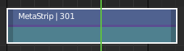
Creates a meta strip out of the selected strips. A Meta Strip is a strip which contain multiple strips treated as if it was one strip. It allows you to reduce the vertical space used in the Sequencer. You can edit it the same way as any other strips.
Note! The default blend mode for a Meta strip is Replace. There are many cases where this alters the results of the animation so be sure to check the results and adjust the blend mode if necessary.

UnMeta Strip
Separating (ungrouping) the Meta strip restores the strips to their relative positions and channels.

Toggle Meta
Toggles between the meta and unmeta state. You need to have a meta strip in the sequencer timeline already.

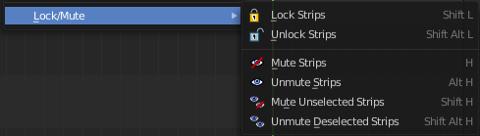
Lock/Mute

Lock Strips
Locks the strip from editing. They can't be moved or edited anymore.

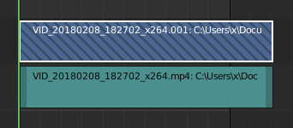
Locked strips appears hatched.

Unlock Strips
Unlock locked strips.

Mute Strips
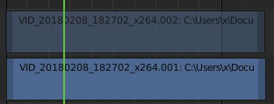
Mutes the selected strips. They do not play anymore, and they appear greyed out.

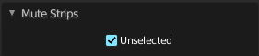
Last operator Mute Strips

Unselected
Mute unselected strips.

Unmute Strips
Unmutes selected muted strip.

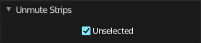
Last operator Unmute Strips

Unselected
Unmute unselected strips.

Mute unselected strips
Mute the unselected strips.

Last operator Mute Strips

Unselected
Mute unselected strips.

Unmute deselected Strips
Unmute all deselected strips.

Last operator Unmute Strips

Unselected
Unmute unselected strips.

Quick Favorites menu


When you right click at a menu or a button, then a right click menu will open. Tools have usually a Add to Quick Favorites menu entry.

The Quick Favorites Menu is empty by default. With Add to Quick favorites you can add this menu to the Quick menu.

In the 3D view we have a menu called Quick in the header, which shows this content then. In the Image Editor you can just call it with its hotkey. Q. It has no regular menu entry here.

Hotkey only functionality

Important! These hotkeys works with the default Bforartists key map And they do not list the Ndof hotkeys. Ndof is a 3d connexion mouse device that is also used for tablets.
Most of the tools can be found in the graphical UI. But there are still some tools that are hotkey only. Some have a UI brother with equal functionality. For example, Pick shortest path is the hotkey sister of Select shortest path. Some are hotkey only since they cannot be integrated in the graphical UI. Like calling the File menu under the mouse. Or mouse position dependent functionality like selecting an edge loop.
The navigation hotkeys and the context menus are excluded here since they are already covered.

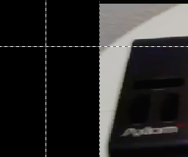
Context Set - O
Preview view. Context Set for overlay frame. Calls a box select tool.

